-



Project 2

Amazon Pantry Project



A SIMPLILEARN PROJECT

FOR BUSINESS ANALYST CAPSTONE COURSE

**SUBMITTED BY: Shubham Saxena**

**Company’s Requirement**

1. Existing system should have a new feature called ABC Pantry
2. On clicking this feature, it would open up a new range and categories of products.
3. This feature should be at a prominent visible area of the existing website or app.
4. There should be a logical grouping of products for customers to search for daily essential items they wish to buy. The following categories should be included:

* Flour and rice
* Sugar, salt, and spices
* Pulses
* Personal care
* Snacks
* Hand wash and sanitizers
* Household cleaning essentials
* Breakfast food items
* Tea and coffee
* Baby care
* Female hygiene
* Tissues and fresheners

1. ABC Pantry should be able to show five advertisements to earn the advertising revenues. These advertisements should not be too intrusive to spoil the customer interaction with ABC Pantry.
2. ABC Pantry should have a feature to show certain offers that are created for customers. They have found that many customers tend to buy products under the offers laid out by them.
3. Customers should be able to add these items to their shopping cart. This cart may have items from ABC company’s nonessential products as well.
4. The software should not allow the user to place an order of an amount less than 30 USD. Individual items can be less than 30 USD but the total order price has to exceed 30 USD.
5. Free Delivery will be offered only if the total order exceeds 50 USD.
6. Currently ABC Pantry would have a presence only in certain cities that are mentioned in the data sets.
7. In the US Market, ABC Company has categorized cities into 4 zones based on their sales in that city. Cities falling under zone 1 have the highest sales. The sales in various zones are zone 1 > zone 2 > zone 3 > zone 4
8. Management wants certain reports at the end of the day. Please give the report formats for the following reports:

* Total sales for each day
* Total sales for each product category as mentioned in point four.
* Total sales across USA
* Total sales for each city.
* Total sales for each zone that city falls into (that is, zone 1, 2, 3, and 4)
* Identify best-selling categories
* Identify the worst-selling categories
* Total sales of each week city wise
* Identify which day of the week shows highest booking by customers

**List Of Project Tasks**

**Project Task Week 1**

1. Identifying Stakeholders – Create a list of Stakeholders (as taught in Business Analysis Planning and Monitoring Knowledge Area)
2. Create As-Is and Future Process map (using flowcharts). You can use any of the popular tools in the market like Microsoft Visio, Lucid Chart, Creately, Pidoco, or Balsamiq
3. As a Business Analyst working on this project, find out the scope of the feature ABC Pantry. Write down the main features that need to be developed.
4. Write the in-scope and out-of-scope items for this software.
5. Write out the business requirements, both functional and nonfunctional Requirements
6. Draw wireframes or mock screens for any two of the features. Use the technique prototyping or wireframing that is taught in the training. You can use any of the wireframing tools like Microsoft PowerPoint, Microsoft Word, Balsamiq, Sketch, Adobe XD, Adobe ILLustrator, Figma, UXPin, InVision Studio, Invision Freehand, or Moqups.

**Project Task Week 2**

1. Make a product backlog of user stories for the given case study. User Stories should be in the format of As a <type of user>, I want <goal> so that <reason>
2. For each story, write the acceptance criteria.

**Questions 1**

1. Create a bar graph showing the sales. Label the chart correctly so that senior management gets a clear report of sales.
2. Arrange the data above in excel in ascending and descending order.

**Questions 2**

1. Create bar graphs of sales for zone 1 cities
2. Find total sales across all cities

**Questions 3**

1. Using vlookup for product code HS, find sales in Phoenix
2. Using vlookup for product code FR, find sales in Dallas

**Overview & Summary**

ABC Company is the world’s leading online e-commerce company. They started by selling books and now have a presence across the world selling more than 6 million items globally.

Most of the products that dominate ABC Company’s sales are non-essential products like fashion products, electronic gadgets, mobile phones, beauty products, books and home furnishings. But ABC Company has realized that every household will need daily essential products like cereals, snacks, beverages, cleaning products, grooming products and so on. ABC Company is seeing a huge market globally in Daily Essential Products and wants to venture into this side of business.

ABC Company decided to create a new feature known as ABC Pantry which would sell daily essential products. This would be an additional enhancement in the current website/app. This would be ABC Company’s foray into daily essential products which are regular consumption products and would lead to repeat sales every month.

ABC Company has invited Business Analysts trained at Simplilearn to capture the requirements for the creating this software.

**Business Analysis Core Concept Model**

**(BACCM)**

The conceptual framework of business analysis has been captured as outlined in the BABOK guide.

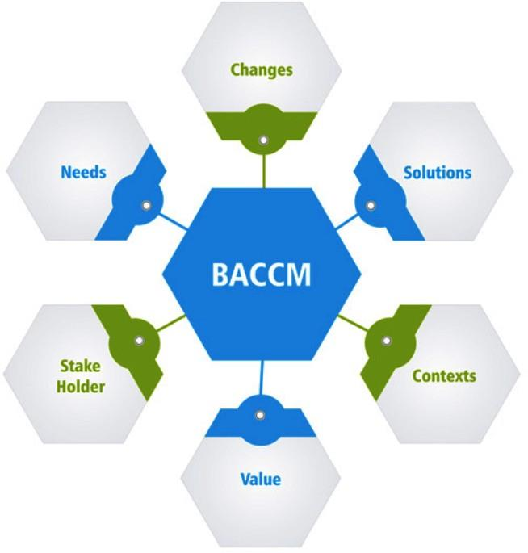

*Business Analysis Core Concept Model as per BABOK*

**Project Task Week 1**

1. Identifying Stakeholders

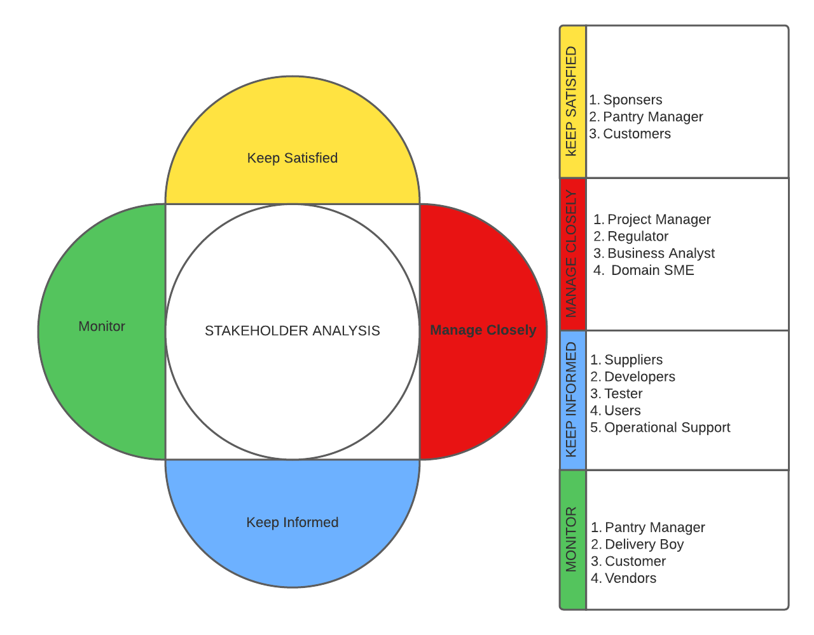

*STAKEHOLDER MATRIX SHOWING THE POWER/INTEREST OF STAKEHOLDERS*

1. As-Is Process and Future Process Map

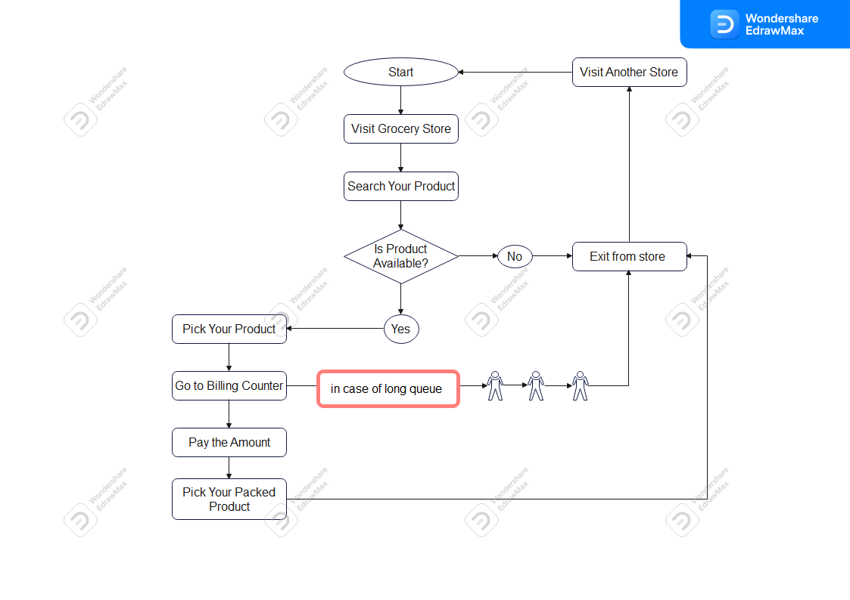

*AS-IS PROCESS MAP*

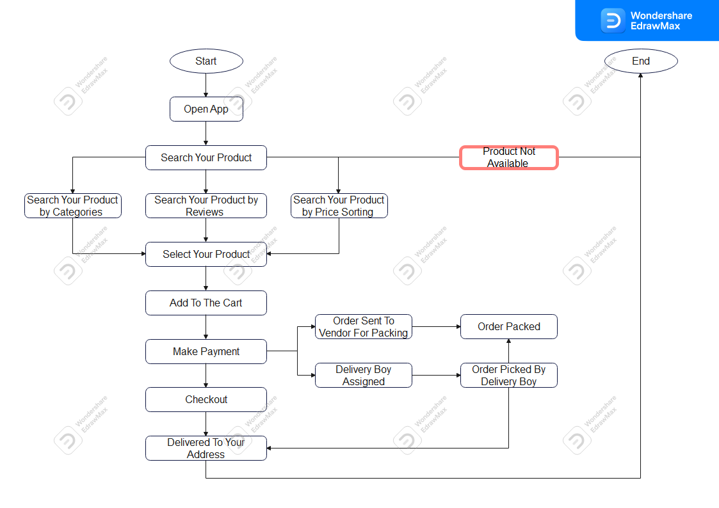

*FUTURE PROCESS MAP*

1. Scope and Main features To be Developed

Below are the main features & scope of the system which needs to be developed:

* Existing system should have a new feature called ABC Pantry
* On clicking this feature, it would open up a new range and categories of products.
* This feature should be at a prominent visible area of the existing website or app.
* There should be a logical grouping of products for customers to search for daily essential items they wish to buy. The following categories should be included:
* Flour and rice
* Sugar, salt, and spices
* Pulses
* Personal care
* Snacks
* Hand wash and sanitizers
* Household cleaning essentials
* Breakfast food items
* Tea and coffee
* Baby care
* Female hygiene
* Tissues and fresheners
* ABC Pantry should be able to show five advertisements to earn the advertising revenues. These advertisements should not be too intrusive to spoil the customer interaction with ABC Pantry.
* ABC Pantry should have a feature to show certain offers that are created for customers. They have found that many customers tend to buy products under the offers laid out by them.
* Customers should be able to add these items to their shopping cart. This cart may have items from ABC company’s nonessential products as well.
* The software should not allow the user to place an order of an amount less than 30 USD. Individual items can be less than 30 USD but the total order price has to exceed 30 USD.
* Free Delivery will be offered only if the total order exceeds 50 USD.
* Currently ABC Pantry would have a presence only in certain cities that are mentioned in the data sets.

1. In-Scope and Out-Scope Requirement

**IN-SCOPE REQUIREMENT FOR THE SOFTWARE**

|  |  |
| --- | --- |
| *In-Scope Requirement* | |
|  |  |
|  |  |
|  |  |
|  |  |
|  |  |
|  |  |
|  |  |
|  |  |
|  |  |

1. Functional and Non-functional Requirement

**FUNCTIONAL REQUIREMENT FOR THE SOFTWARE**

|  |  |
| --- | --- |
| *Functional Requirement* | |
|  |  |
|  |  |
|  |  |
|  |  |
|  |  |
|  |  |
|  |  |
|  |  |
|  |  |

1. Wire-frame or Mock-screen

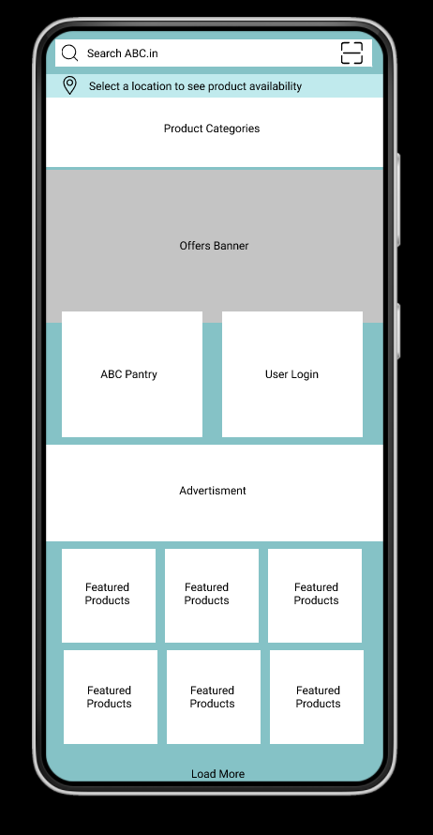

*ABC HOME PAGE*

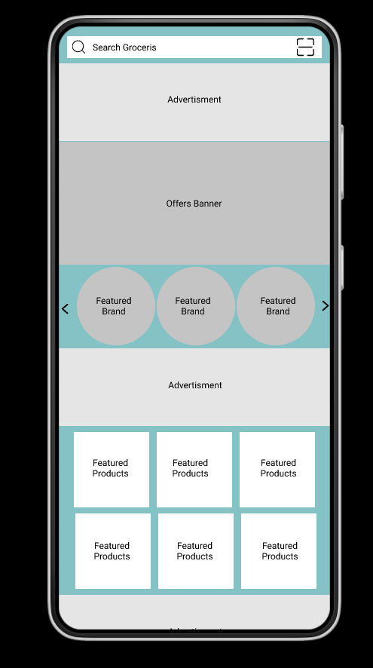

*ABC PANTRY HOME PAGE*

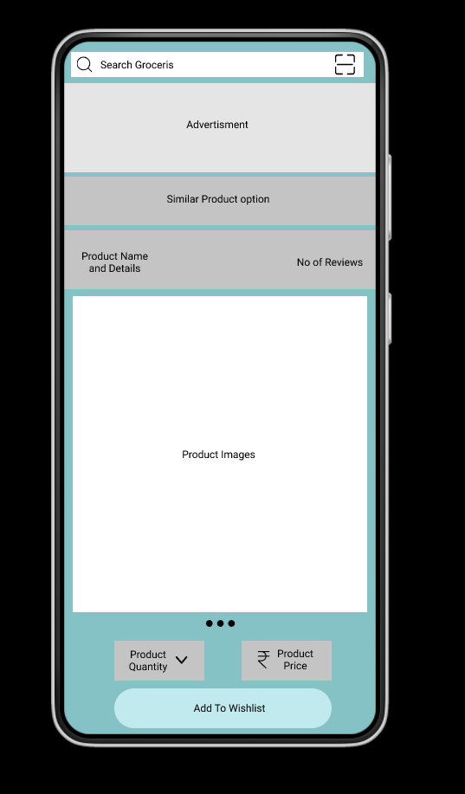

*ABC PRODUCT PAGE*

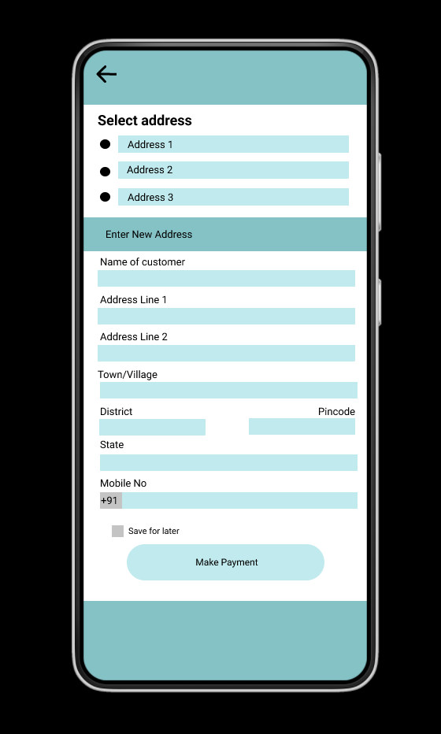

*ABC ADDRESS PAGE*

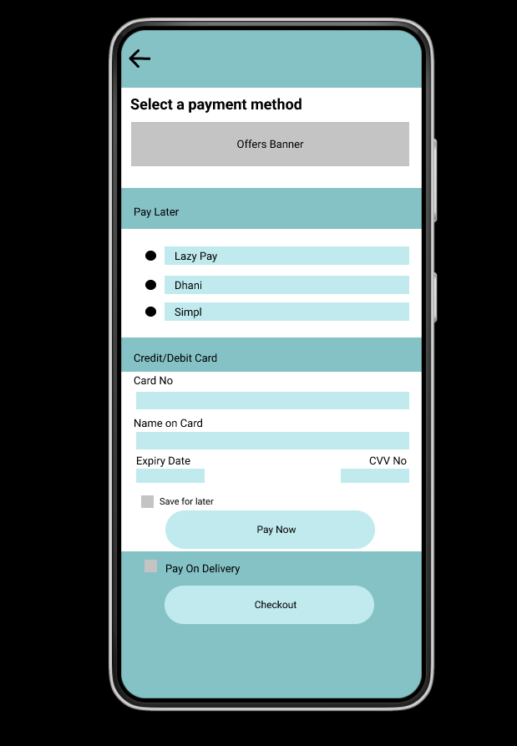

*ABC PAYMENT PAGE*

**Project Task Week 2**

1. Project Creation

* Creating Project On Jira Software

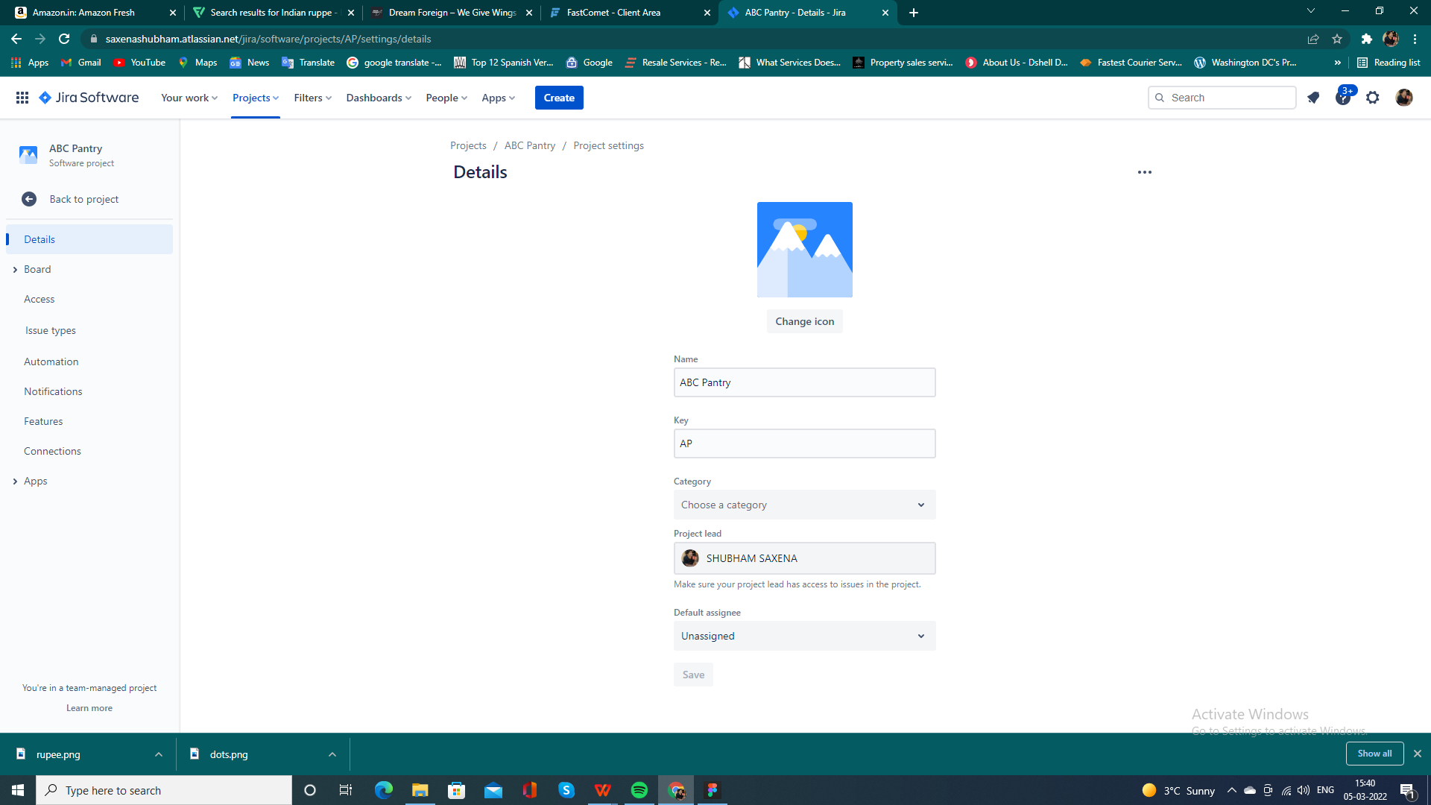

* Creating issues (Story)

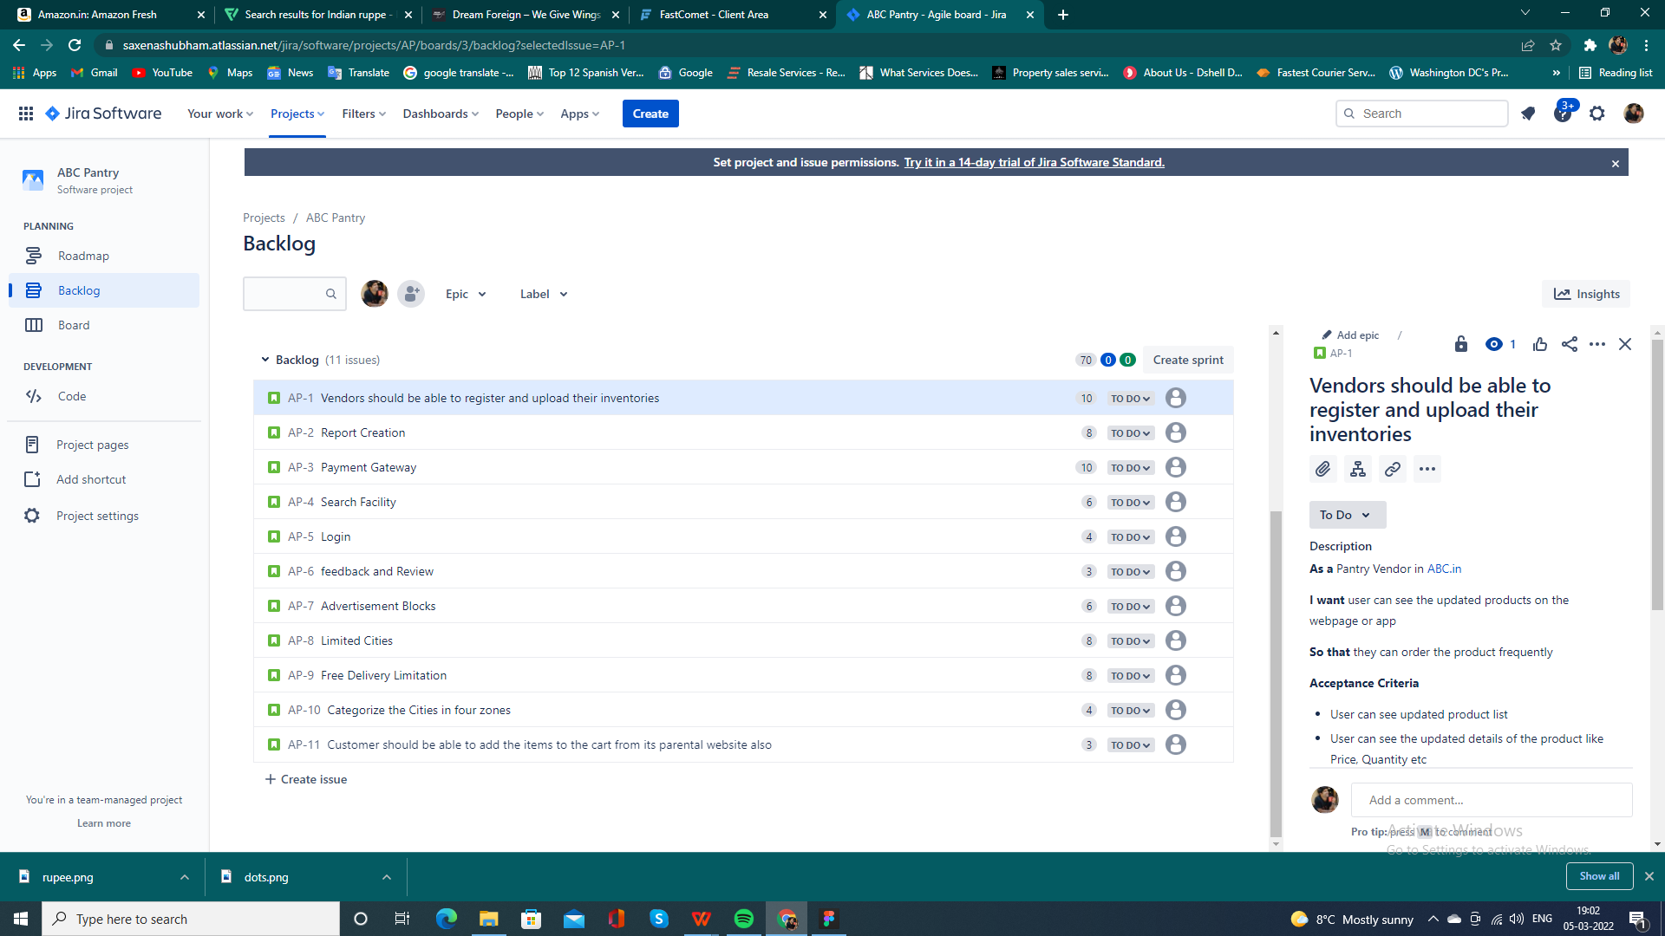

* Epic Creation

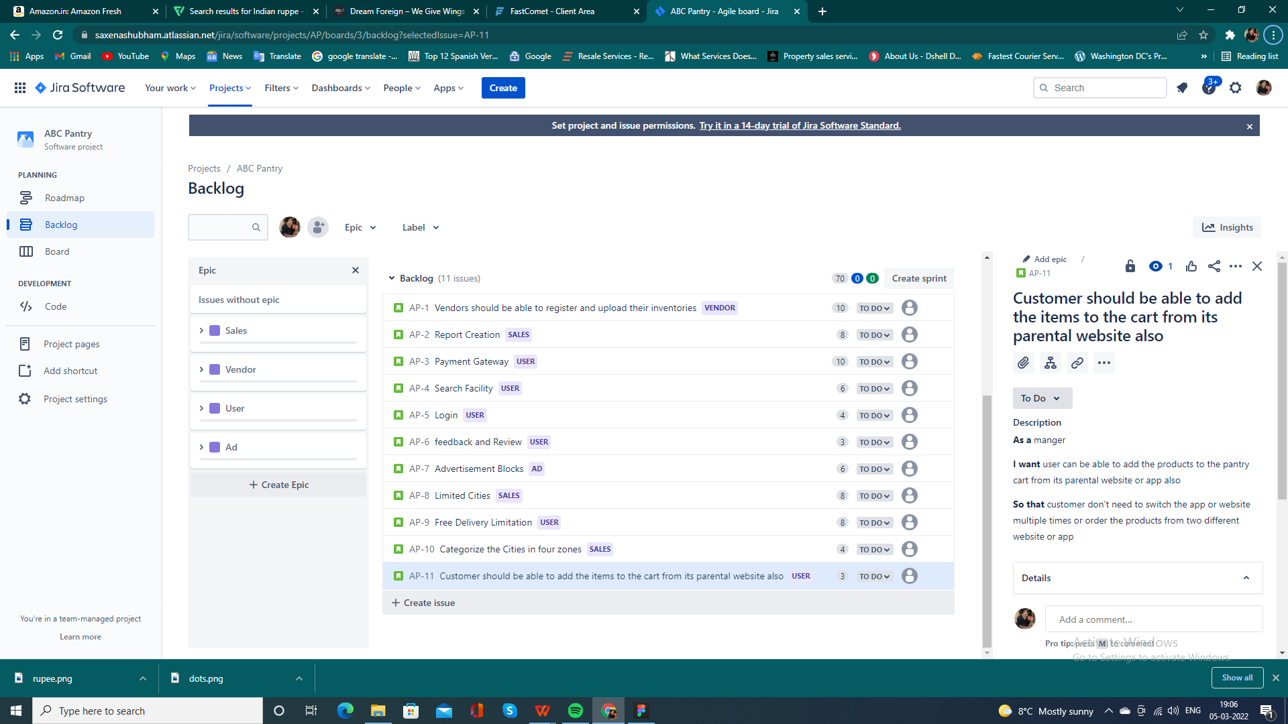

1. User Acceptance for stories

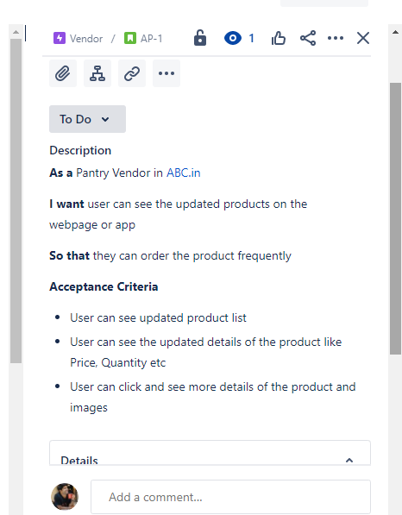

* Starting of sprint

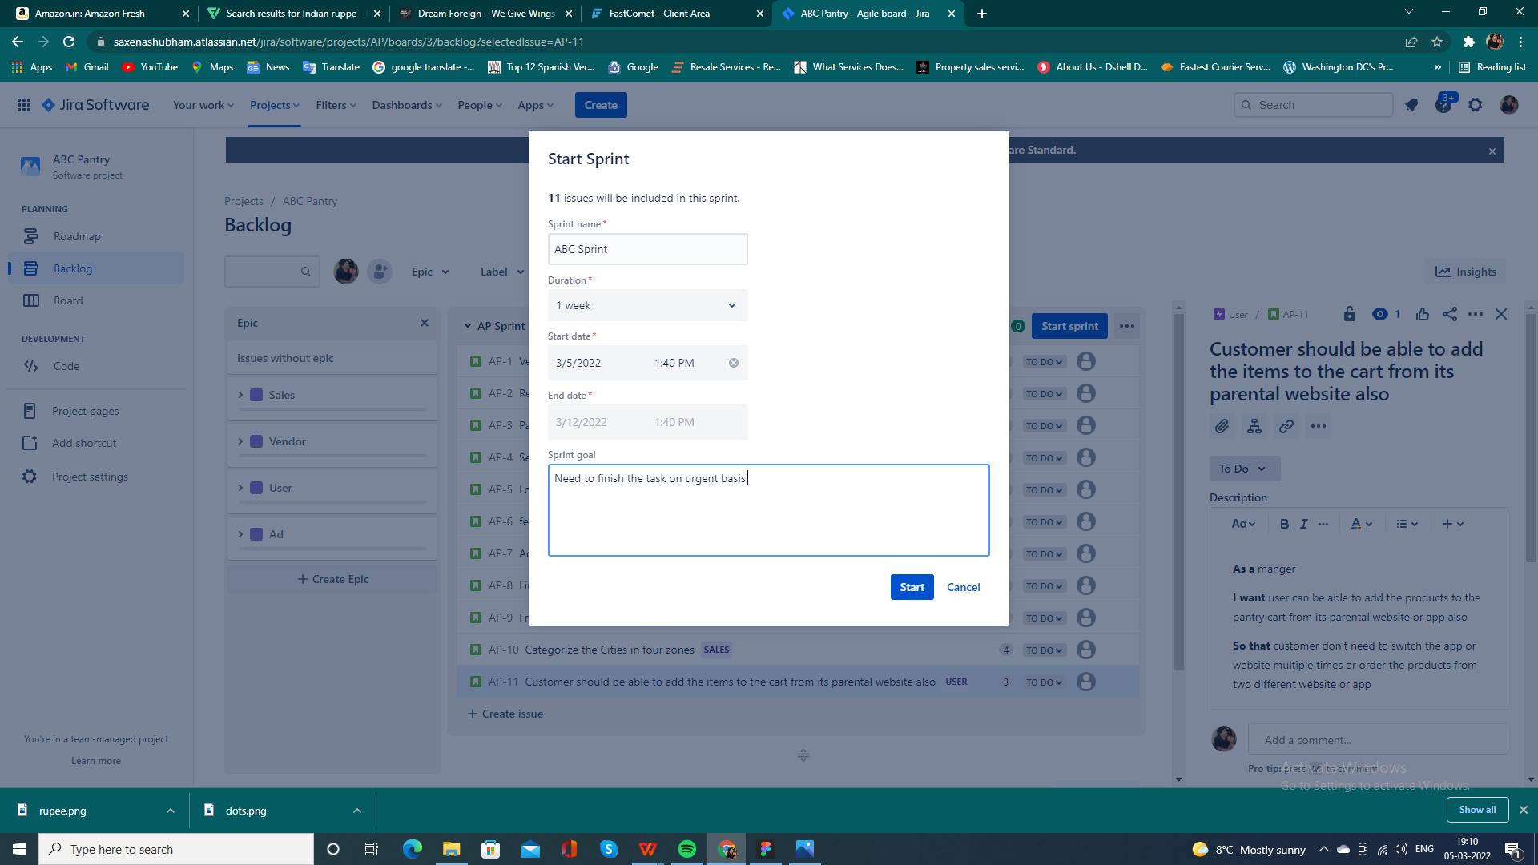

* Sprint in progress and done report

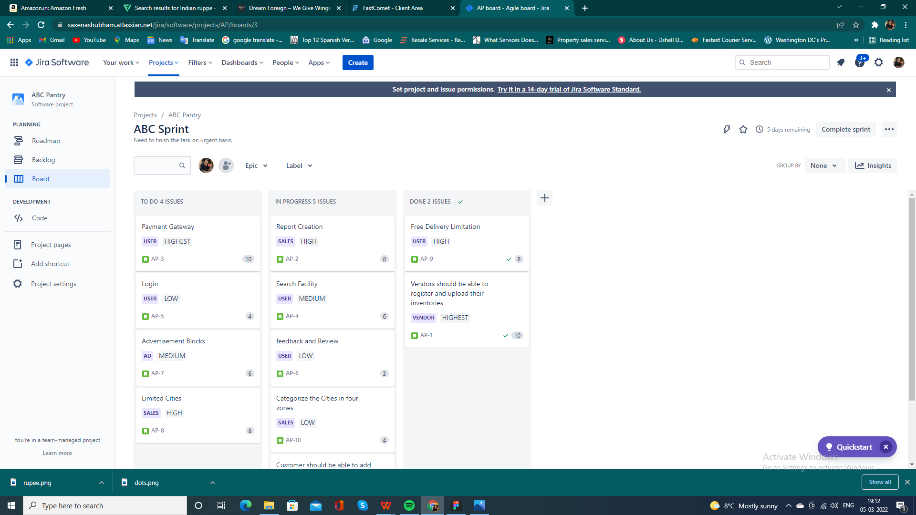

* Completion Of Sprint

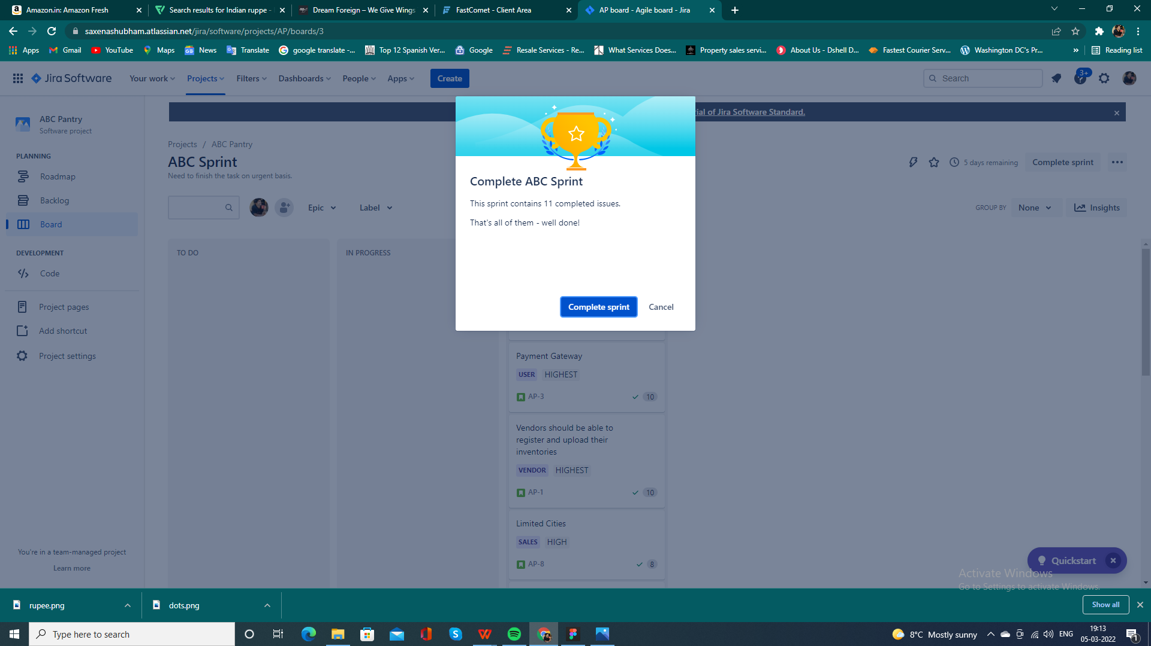

* Burnup report

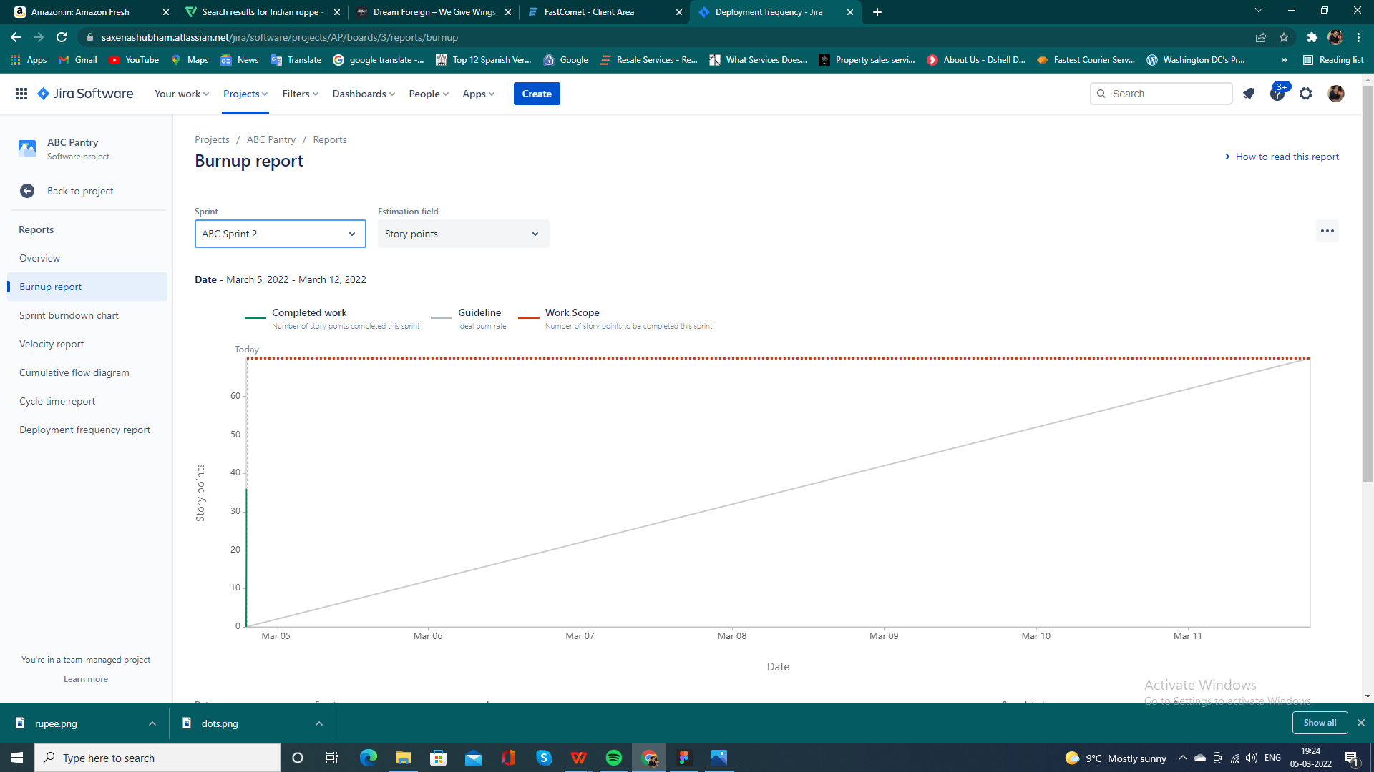

* Sprint Burndown Report

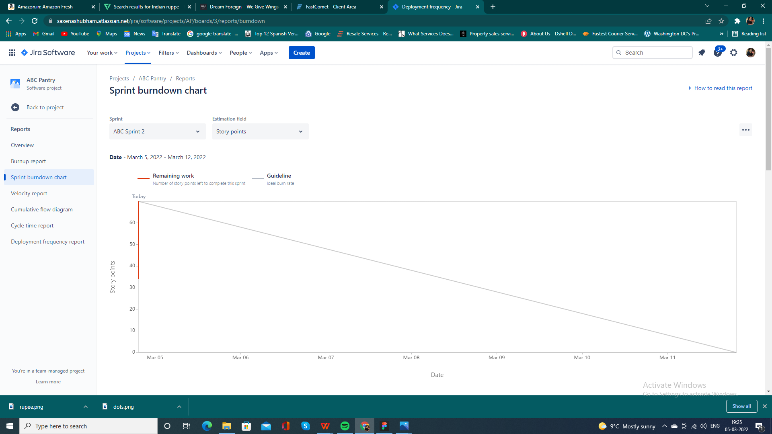

* Velocity Report

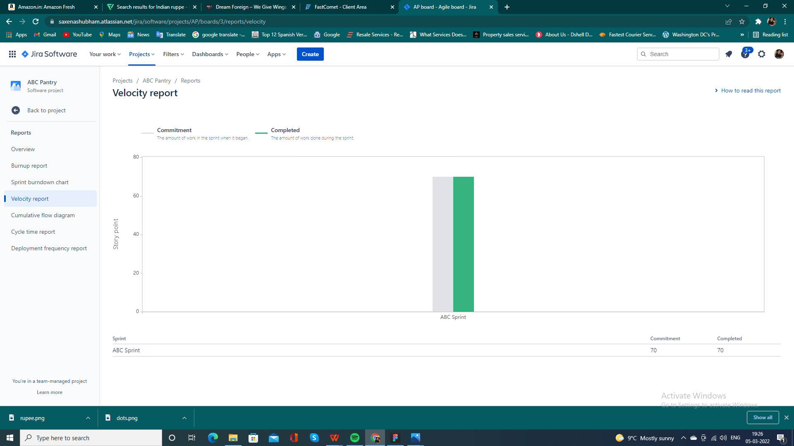

* Cumulative flow Diagram

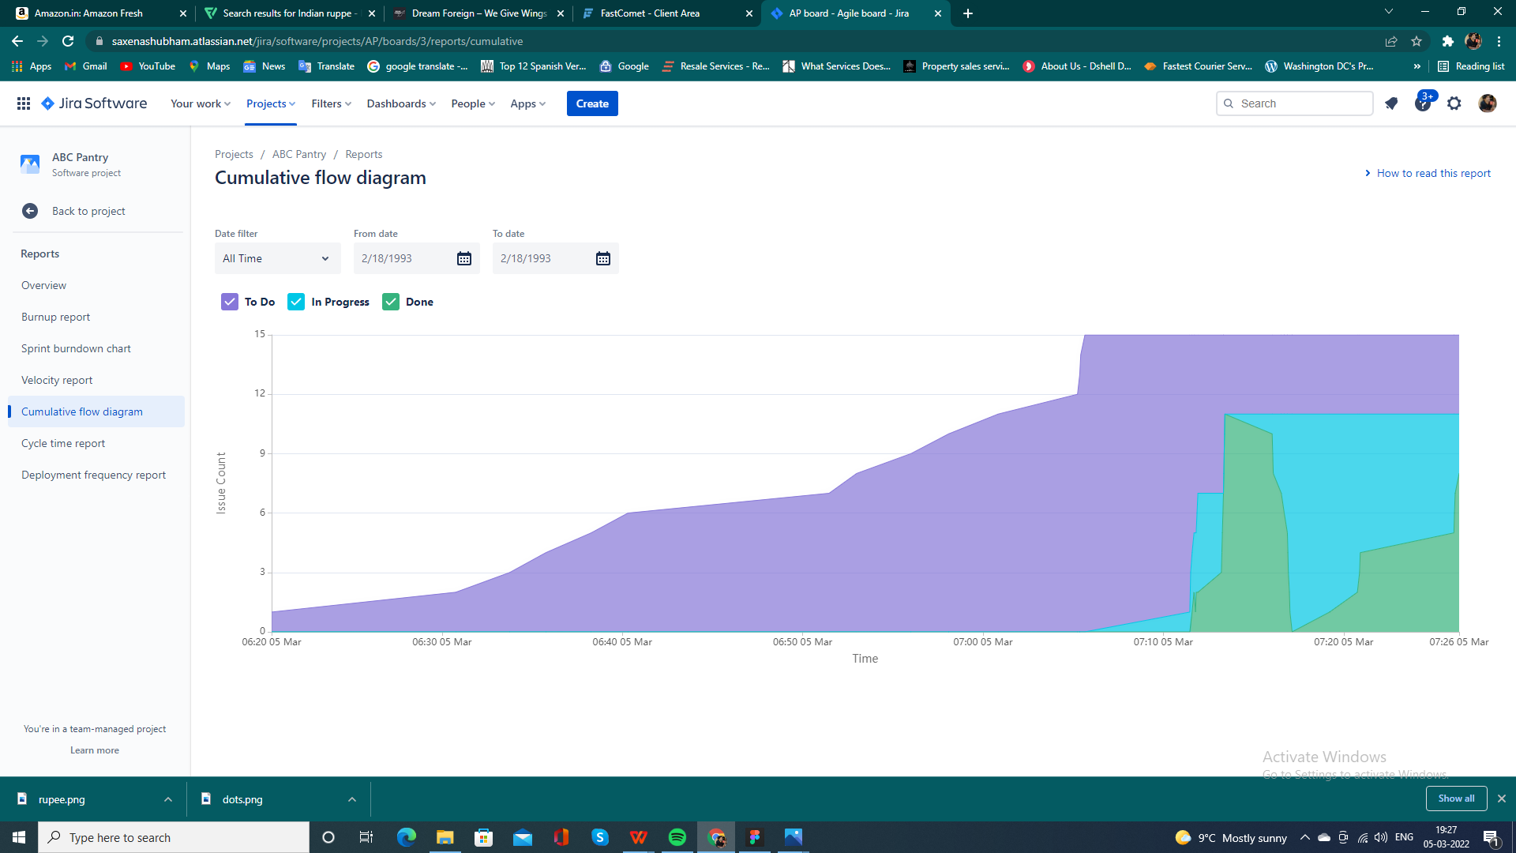

* Updated Backlogs

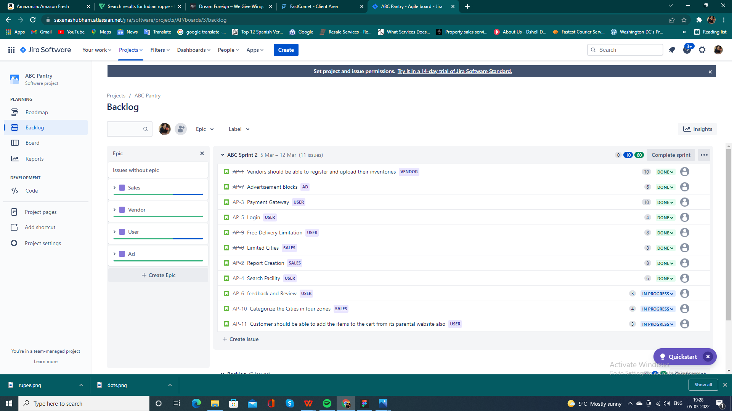

**Questions 1**

1. Create a bar graph showing the sales. Label the chart correctly so that senior management gets a clear report of sales.